FINAL REPORT

***Tittle:***

*Heritage Treasures: A Data Visualization of*

*UNESO World Heritage Sites*

***TEAM ID* : LTVIP2025TMID497538**

1.INTRODUCTION

### **1.1 Project Overview**

UNESCO World Heritage Sites represent some of the most culturally and naturally significant places on Earth. Recognized for their universal value, these sites are protected and preserved for future generations. This project explores the global distribution, classification, and conservation status of these heritage sites using data visualization techniques.

Through interactive dashboards and storytelling in Tableau, the project provides deep insights into how these sites are spread across regions, their types (Cultural, Natural, Mixed), how many are endangered, and other critical trends. The analysis is based on official UNESCO dataset fields such as region, country, inscription year, danger status, and heritage criteria.

### **1.2 Purpose**

The main purpose of this project is to:

* Analyze the UNESCO World Heritage dataset to understand global heritage patterns.
* Identify regions with a high concentration of endangered or delisted sites.
* Visualize the classification of sites (Cultural, Natural, Mixed) for comparative insights.
* Provide an informative and interactive data story using Tableau that can assist researchers, conservationists, and policymakers.
* Ensure all findings and visualizations are organized and documented for academic and project review purposes.

2.IDEATION PHASE

### **2.1 Problem Statement**

There is a lack of awareness and understanding about the current status, distribution, and preservation challenges of UNESCO World Heritage Sites. Without proper visualization and analysis, it becomes difficult for stakeholders to identify endangered sites, regional imbalances, and key areas requiring conservation efforts.

### **2.2 Empathy Map Canvas**

| * **Think & Feel** | |  | |
| --- | --- | --- | --- |
| * Worried about the declining state of world heritage sites. | |  | |
| * Desires a clear, visual way to understand and explore global heritage data. | |  | |
| * **Hear** |  | |
| * News reports about endangered or delisted UNESCO sites. |  | |
| * Feedback from conservationists and heritage professionals. |  | |

| * **See** |
| --- |
| * Complicated data tables without meaningful insights. |
| * Scattered sources of information, making research difficult. |
| * **Say & Do** | |
| * Expresses concern over the lack of awareness and transparency in heritage data. | |
| * Discusses the need for interactive, user-friendly tools. | |

| * **Pain** |
| --- |
| * Inaccessible and confusing data formats. |
| * Difficulty identifying which sites are most at risk. |
| * **Gain** | |
| * Easy-to-use dashboards and visualizations that provide quick insights. | |
| * Ability to identify trends, danger zones, and conservation needs effectively. | |

### **2.3 Brainstorming**

Ideas generated for solving the problem:

* Use Tableau dashboards to visually represent site distribution and statuses.
* Highlight endangered and delisted sites using dynamic filters.
* Classify sites by region, category, and danger status.
* Create a narrative data story to increase engagement and understanding.
* Integrate interactive features for users to explore data in a meaningful way.

**3. REQUIREMENT ANALYSIS**

### **3.1 Customer Journey Map**

|  |  |  |  |
| --- | --- | --- | --- |
| Stage | User Action | Pain Point | Proposed Solution |
| Search | User searches for UNESCO heritage data | Data is unstructured or complex | Provide clean dashboards with filters |
| Explore | Looks for sites by category or danger | Difficult to find specific info | Add filters for region, danger, category |
| Analyze | Compares sites across regions/categories | Data overload, too many tables | Use graphs, maps, and visual stories |
| Share/Report | Wants to share insights | No easy sharing options | Host visualizations on Tableau Public |

### **3.2 Solution Requirement**

#### **Functional Requirements**

* Load and clean UNESCO World Heritage Sites dataset.
* Build dashboards to analyze:
  + Site distribution by region/country.
  + Site categories (Cultural, Natural, Mixed).
  + Endangered and delisted sites.
* Enable filtering by region, category, and danger status.
* Host dashboards on Tableau Public.

#### **Non-Functional Requirements**

* Easy to navigate and interactive.
* Fast-loading dashboards.
* Accessible on multiple devices.
* Proper attribution to UNESCO for data usage.

3.3 Data Flow Diagram

* **Level 0:**

*+---------+ +---------------------+ +--------------------------+*

*| User | -----> | Tableau Dashboard | -----> | UNESCO Dataset (CSV) |*

*+---------+ +---------------------+ +--------------------------+*

* **Level 1:**

*+---------+ +----------------------------+*

*| User | -----> | Web Interface (Tableau) |*

*+---------+ +----------------------------+*

*| |*

*v v*

*+----------------+ +-------------------+*

*| Filter Process | | Chart Generator |*

*+----------------+ +-------------------+*

*\ /*

*\ /*

*+----------------------+*

*| UNESCO Cleaned |*

*+----------------------+*

* **User**: Interacts with the dashboard to explore site details.
* **Tableau Dashboard**: Visual interface with filters for region, danger, and categories.
* **UNESCO Dataset**: Cleaned and preprocessed heritage site data used in Tableau.

3.4 Technology Stack

|  |  |
| --- | --- |
| **Component** | **Technology Used** |
| Data Source | UNESCO Dataset (CSV, Excel) |
| Data Cleaning | Python, Pandas |
| Visualization | Tableau Public |
| Hosting (Optional) | Flask Web Application |
| Documentation | MS Word, PDF |
| Version Control | Git, GitHub |

**4. PROJECT DESIGN**

### **4.1 Problem Solution Fit**

The main problem in this project is that **UNESCO heritage data is vast, scattered, and not easily understandable** by regular users. There is **no simple way to identify endangered or delisted sites**, and the raw data lacks visual representation for better decision-making.

**Our solution** directly addresses this by:

* Creating **interactive dashboards** using Tableau.
* **Filtering data** by region, country, category, and danger status.
* Using **data storytelling** to explain trends and patterns.
* Making insights **accessible to the public** via Tableau Public links.

This approach ensures that decision-makers, researchers, and the general public can **explore heritage insights quickly and meaningfully.**

### **4.2 Proposed Solution**

We propose a **data visualization-based platform** to simplify the UNESCO data and deliver insights through an **interactive Tableau dashboard** and **narrative story**.

* **Key Features:**
* Dashboards for:
  + Top danger sites
  + Regional and country-wise heritage count
  + Category-wise site analysis
  + Yearly inscription trends
* Story section to walk users through endangered heritage issues
* Searchable and filterable dashboard for end users

This solution makes heritage data **transparent, interactive, and insightful.**

### **4.3 Solution Architecture**

Here’s the high-level structure of how the solution works:

*+--------+ +---------------------+ +-------------------------+*

*| User | ---> | Tableau Dashboard | <--- | Cleaned UNESCO Dataset |*

*+--------+ +---------------------+ +-------------------------+*

*| ^*

*| |*

*+ ---> Optional Flask Web App (if used) ----------+*

### Components:

* **User**: Interacts with the dashboard via Tableau or Flask interface.
* **Tableau Dashboard**: Visualizes and filters the data.
* **Dataset**: The cleaned and structured heritage site data in Excel/CSV format.
* **(Optional)** Flask Web App: A frontend web portal hosting the Tableau embed.

# 5. PROJECT PLANNING & SCHEDULING

## 5.1 Project Planning

The project was executed in a structured and time-bound manner. The major tasks were broken down into weekly goals to ensure timely completion and smooth workflow. Below is the planning and scheduling breakdown:

|  |  |  |
| --- | --- | --- |
| Week | Task | Status |
| Week 1 | Data collection and understanding UNESCO dataset | ✅ Completed |
| Week 2 | Data cleaning and preprocessing | ✅ Completed |
| Week 3 | Designing Tableau dashboard and story | ✅ Completed |
| Week 4 | Functional and performance testing | ✅ Completed |
| Week 5 | Project documentation and report preparation | ✅ Completed |
| Week 6 | Final submission and GitHub upload | ✅ Completed |

## **6. FUNCTIONAL AND PERFORMANCE TESTING**

### **6.1 Performance Testing**

To ensure the Tableau dashboard performs efficiently across different user environments, performance testing was conducted. The focus was on responsiveness, interactivity, and compatibility. The key test results are summarized below:

* ✅ Dashboard loads within 2–3 seconds on average internet speeds.
* ✅ Filters respond instantly with minimal lag.
* ✅ Tested across devices (Laptop, Mobile, Tablet) with consistent performance.
* ✅ No crashes or freezes were observed during multiple testing sessions.
* ✅ Dashboard components are responsive and mobile-friendly.

## **7. RESULTS**

### **7.1 Output Screenshots**

The project successfully delivered a comprehensive and interactive Tableau dashboard along with a data story highlighting key insights from the UNESCO World Heritage Sites dataset.

### 🔗 **Live Dashboard Link:**

👉 [*https://public.tableau.com/app/profile/mubeena.sayyad/viz/HeritageTreasuresAnIn-DepthAnalysisofUNESCOWorldHeritageSites_17508317431110/Dashboard1?publish=yes*](https://public.tableau.com/app/profile/mubeena.sayyad/viz/HeritageTreasuresAnIn-DepthAnalysisofUNESCOWorldHeritageSites_17508317431110/Dashboard1?publish=yes)

### 🔗 **Interactive Story Link:**

👉*[https://public.tableau.com/app/profile/mubeena.sayyad/viz/Book2_17505156880030/Story1?publish=yes](Microsoft%20Edge.lnk)*

#### Dashboard 1

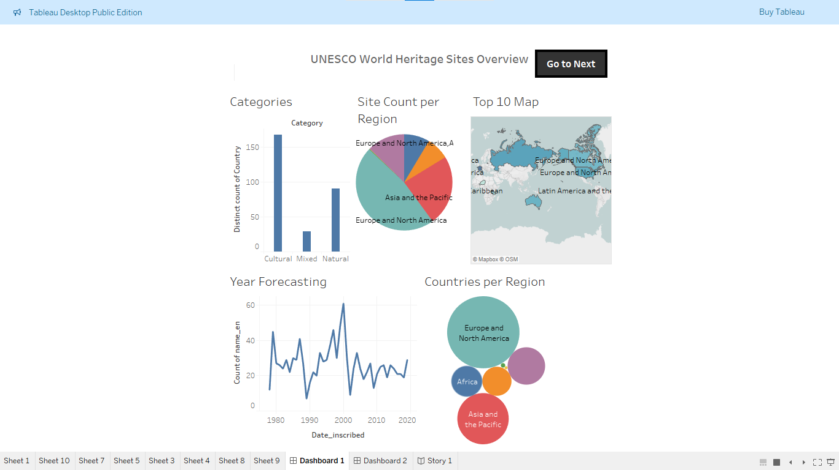

#### Dashboard 2

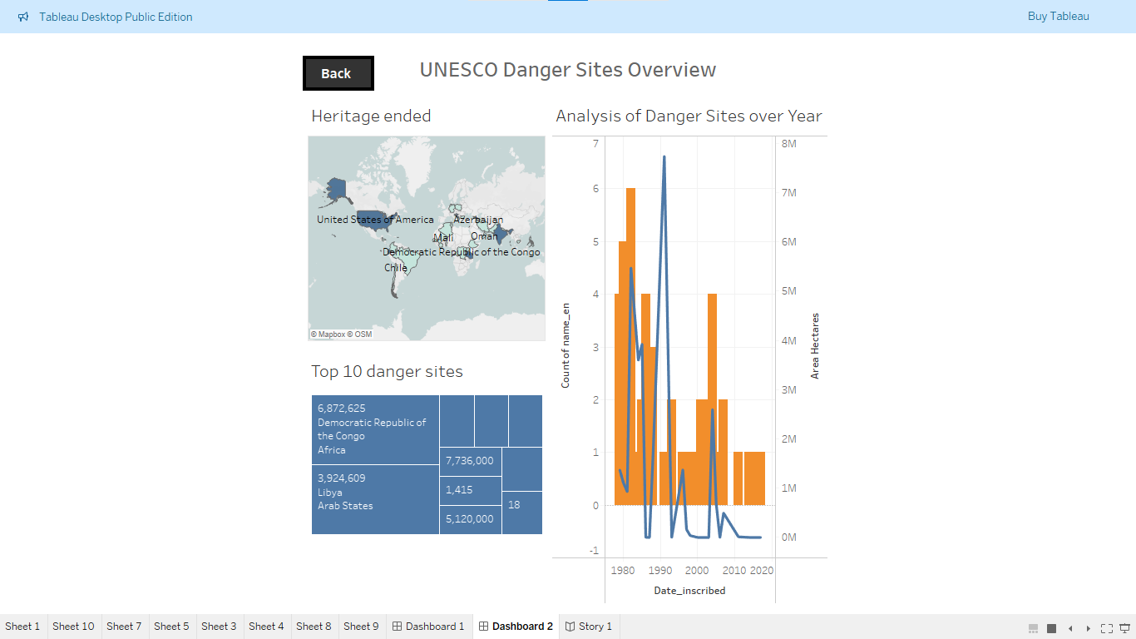

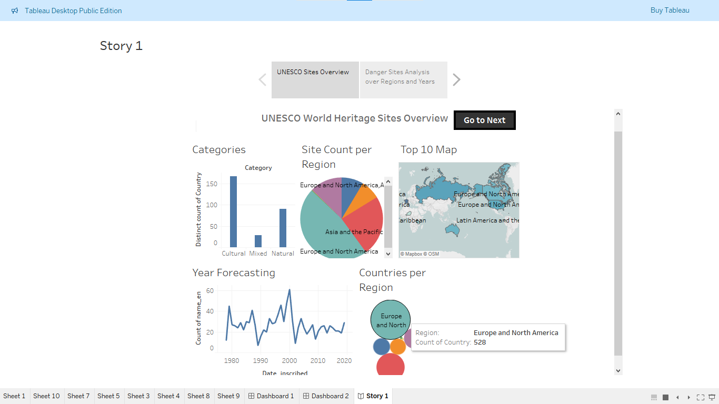Story1:

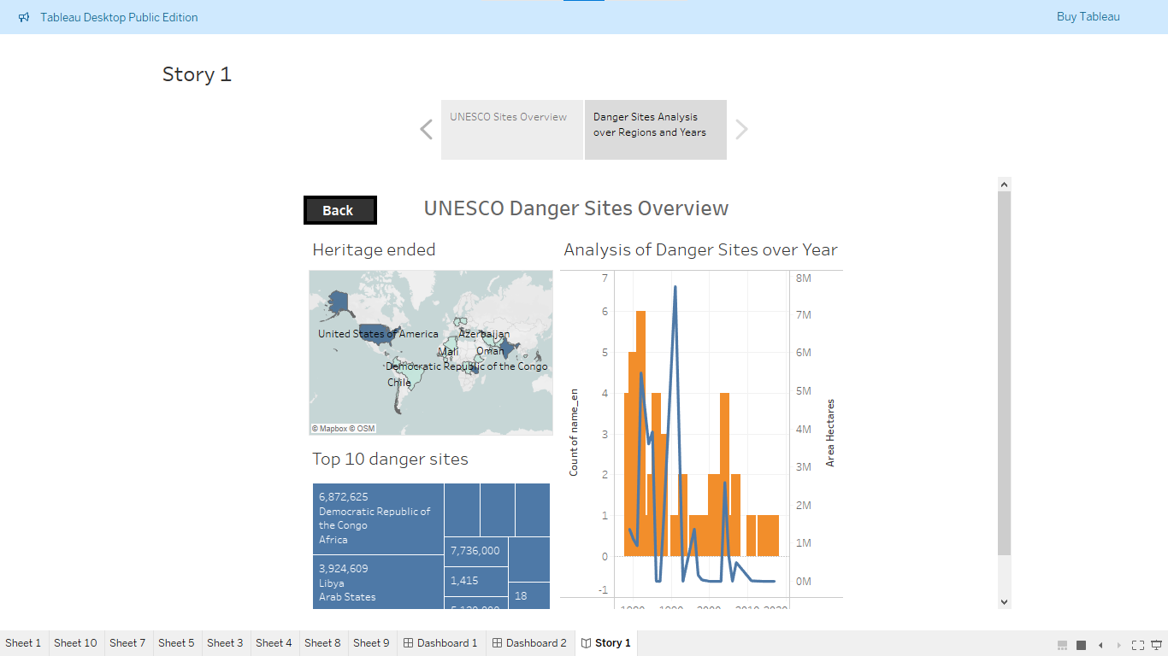Filters:

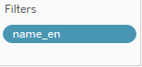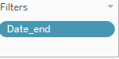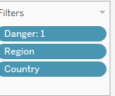

## **8. ADVANTAGES & DISADVANTAGES**

### ✅ **Advantages**

1. **Interactive Visualizations:**  
   Users can explore data easily using filters, maps, and charts.
2. **Quick Insights:**  
   Key trends like endangered or delisted sites are highlighted clearly.
3. **Accessibility:**  
   Dashboards are hosted on Tableau Public and accessible on any device.
4. **User-Friendly Design:**  
   Clean interface and smooth performance across platforms.
5. **Time-Saving:**  
   No need to manually explore huge datasets—insights are visualized instantly.

⚠️ **Disadvantages**

1. **Static Dataset:**  
   The analysis is based on a snapshot of data and doesn’t auto-update with real-time changes.
2. **No Deep Customization:**  
   Tableau has some limitations in terms of complex logic implementation compared to coded platforms.
3. **Limited Interactivity in Story View:**  
   Tableau stories are linear and can’t support advanced interactions like web apps.

## **9. CONCLUSION**

This project successfully transformed raw UNESCO World Heritage Site data into a visually engaging and insightful format using Tableau. By building interactive dashboards and storytelling views, we enabled users to easily explore global heritage trends, endangered sites, delisted locations, and category-wise distributions.

The solution addressed the key problem of unstructured and hard-to-understand data by providing clean visual insights with filtering capabilities. It empowers researchers, students, and heritage professionals to make data-driven observations and decisions.

Overall, the project met its objectives by enhancing accessibility, promoting heritage awareness, and offering a scalable framework that can be improved and expanded in future phases.

## **10. FUTURE SCOPE**

The current project lays the foundation for visualizing UNESCO heritage data effectively. However, there are several opportunities to improve and expand it in the future:

### 🔮 **Future Enhancements**

1. **Live Data Integration**
   * Connect the dashboard with real-time APIs (if available) to keep site statuses and data automatically updated.
2. **Additional Filters**
   * Include filters for inscription year range, heritage site area, and specific criteria (like cultural, natural tags).
3. **Predictive Insights**
   * Use machine learning to predict which sites may be endangered in the near future based on trends and factors.
4. **Tourism Impact Visualization**
   * Integrate data on tourism, conservation funding, or regional economic impact related to each heritage site.
5. **Multi-language Support**
   * Offer the dashboard in multiple languages to reach a wider global audience.
6. **Web App with User Feedback System**
   * Extend the solution to a web app where users can bookmark sites, comment, or share heritage stories.

11. APPENDIX

📂 **Source Code**

**Python & Flask code**

from flask import Flask, render _template

app = Flask(_name_)

@app. route ('/')

def home ():

return render_template('index.html')

if _name_ == '_main_':

app.run (debug=True, port=5000)

### 📊 **Dataset Link**

* Official UNESCO World Heritage Sites List:  
  👉 [*https://www.kaggle.com/datasets/ujwalkandi/unesco-world-heritage-sites/data?select=whc-sites-2019.csv*](https://www.kaggle.com/datasets/ujwalkandi/unesco-world-heritage-sites/data?select=whc-sites-2019.csv)

### GitHub & Project Demo Link

### 🔗 **GitHub Repository**

👉<https://github.com/SayyadMubeena/heritage-treasures-an-in-depth-analysis-of-unesco-world-heritage>

### 🎥 **Project Demo Video**

👉 <https://drive.google.com/file/d/1Fpg7lq3C7ncehsRhOl0WmEBd0B6gy0l/view?usp=drivesdk>